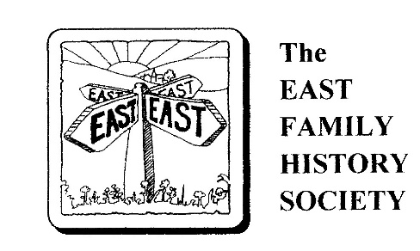
Membership Application Form
(For Overseas Members)

Title : Surname:
Forenames:
Address Line 1:
Address Line 2:
Address Line 3:
Post/Zip code: Country:
Telephone: E-mail:
I agree to pay my annual subscription of £15 (GBP) by Bank Xfer to :-
Bank : NatWest A/C Name: The East Family History Society
IBAN Code: GB52 NWBK 6002 2365 4997 27
SWIFT Address: NWBKGB2LXXX
Account Address: 10, Aldbourne Road, Burnham, Slough, SL1 7NJ, UK.
I understand I will receive my biannual copy of Points East in PDF format
General Data Protection Regulation, 2018: By signing this form you are confirming that you are consenting to the East Family History Society holding and processing your personal data for the purpose of contacting you by post, telephone and email. Your data will not be released for use outside the Society. Our full Privacy Notice is available on our website.

Signed………………………….. Date………………………….
Please return this completed form to: The Secretary
The East Family History Society

e-mail: easts@waternet.plus.com

