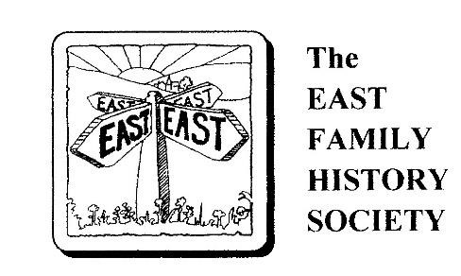

Membership Application Form

Title : | Surname:
Forenames:
Address Line 1:
Address Line 2:
Address Line 3:
Post/Zip code: Country:
Telephone: E-mail:
I will pay my subscription, £15, by:
Standing Order ( )
Cheque (drawn on a UK Bank) ( ) please tick
Bank Xfer (FPS) ( )
Please make cheques payable to The East Family History Society
Bank : Natwest A/C Name: The East Family History Society
Sort Code: 60-02-23 A/C Number: 65499727
All members receive a .pdf version of ‘Points East’ by email. Paper copies available on request.
General Data Protection Regulation, 2018: By signing this form you are confirming that you are consenting to the East Family History Society holding and processing your personal data for the purpose of contacting you by post, telephone and email. Your data will not be released for use outside the Society. Our full Privacy Notice is available on our website.

Signed………………………….. Date………………………….

Please return this completed form to: Membership & Research Manager
The East Family History Society
c/o 1, St Johns House,
St Johns Green,
Wallingford, Oxon
OX10 9AB
e-mail: easts@waternet.plus.com

